**HEXADECIMAL TO DECIMAL CONVERSION**  
**EXP NO: 27**

**AIM:** To write a C program to implement hexadecimal to decimal conversion.

**ALGORITHM:**  
1)      Start from the right-most digit. Its weight (or coefficient) is 1.  
2)      Multiply the weight of the position by its digit. Add the product to the result.  
(0=0, 1=1, 2=2, … 9=9, A=10, B=11, C=12, D=13, E=14,F=15)  
3)      Move one digit to the left. Its weight is 16 times the previous weight.  
4)      Repeat 2 and 3 until you go through all hexadecimal digits.

**PROGRAM:**  
#include<stdio.h>

int main()

{

int n;

printf("enter the hex decimal number: ");

scanf("%x",&n);

printf("the decimal value is:%d ",n);

return 0;

}  
  
  
**INPUT:**  
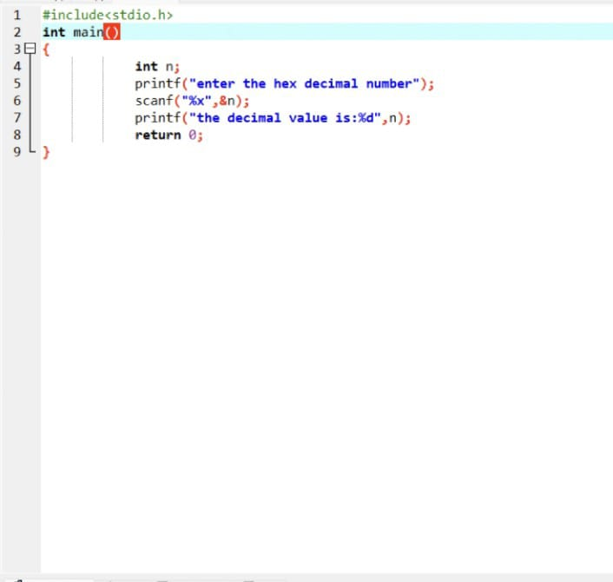  
  
  
  
  
**OUTPUT:**  
  
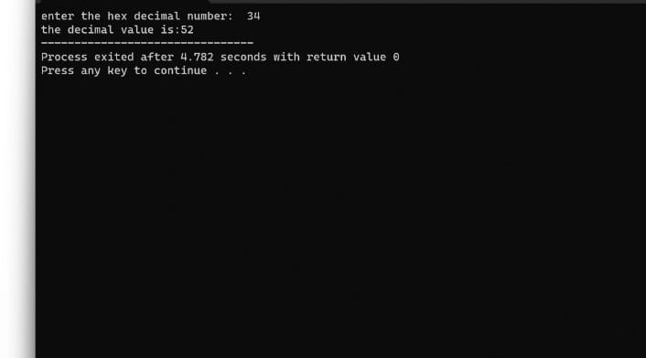  
   
  
  
   
  
  
  
  
  
  
**RESULT:**Thus the program was executed successfully using DevC++.